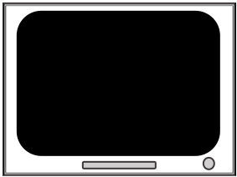

ITI

1000- (SS + SSD)

300, unless SSD > 700 ms, where SS = 1000-SSD

0-900 ms

700-2000 ms

1000-RT

Fixation

Stop Signal

Stop Signal Delay

*Stop Signal Task Design*

Stop Trials

Reaction Time

1000 ms, or RT

700-2000 ms

Fixation

Go Cue

ITI

Go trials

Successful Inhibition